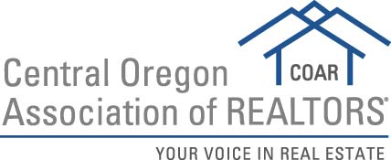

2019 Affiliate of the Year Nomination Form
Please submit to kim@coar.com by February 28, 2019.

Nomination Form

Nominee Name:

Nominee Company:

Please describe how the nominee meets demonstrates each of the following:
- Activity in Local Association (Service on COAR committees and/or board is highly preferred for candidates)

- Professionalism

- Cooperation with Real Estate Offices and Agents

- Promotion of the REALTOR® Organization

- Activity in Community / Civic Affairs

Nomination submitted by:
Date:

