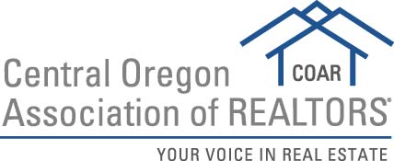

2019 Rookie of the Year Nomination Form
Please submit to kim@coar.com by February 28, 2019
Criteria
Agent should be nominated by their Managing Principal Broker
- Must have been a REALTOR® for at least 24 months and up to 60 months
- Involved in COAR demonstrated by attending events, classes and/or serving on committee(s)
- Expresses motivation to learn more about the real estate field
- Exemplifies a high degree of integrity
- Is involved in his or her community
- Has completed at least 10 transactions (can be a co-agent)
- Has contributed to the firms success
- Displayed leadership with good teamwork skills
- Has exhibited sound moral character and high ethical behavior

Nominee Name:

- Character and Integrity

- Service to Clients

- Professional Knowledge i.e. COAR Classes, Designations, Certifications

- Association Participation. Service on COAR committees and/or board is highly preferred for candidates.

- Community Involvement

- Ethical and Moral Character

- Leadership Skills

Broker’s Signature
Date :

Please Print Name:

